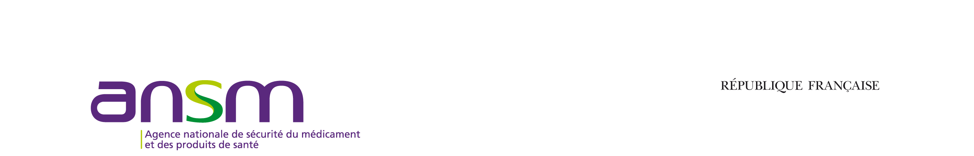

**MA / REGISTRATION APPLICATION FOR SUNSET CLAUSE EXEMPTION: Section to be completed by holders**

Name Strength Pharmaceutical form:

NL/Registration No.:

INN:

MA / registration date:

Marketing status:

* Medicinal product never marketed
* Date of cessation of marketing of the last presentation:

Provisional sunset date:

Exemption previously granted:

* Yes
* No

Application for exemption:

* (1) Public health grounds
* (2) Legal grounds
* (3) Export grounds
* (4) Mutual recognition/decentralised procedure grounds

Additional comments relating to the application for exemption (explanation, list of supporting documents, etc.):

………………………………………………………………………………………………………………………………………………………………………………………………………………………………………………………………………………………………………………………………………………………………………………………………………………………………………………………………………………………………………………………………………………………………………………………………………………………………………………………………………………………………………………………………………………………………………………………………………………………………………………………………………………………………………………………………………………………………………………………………………………………………………………

***DATE / NAME and TITLE / SIGNATURE***

**MA / REGISTRATION SUNSET CLAUSE EXEMPTION: Section reserved for administrative purposes**

|  |
| --- |
| Name of MA or registration holder  Contact details |

The application for an exemption to application of the sunset clause for the abovementioned marketing authorisation(s)/registration(s) is accepted[1]*; it is valid

* + for a maximum period of 5 years from the legal sunset date.
  + for a maximum period of ……………………….. from the legal sunset date.

***DATE / NAME and TITLE / SIGNATURE***

**Outgoing No.:**

1. * *The exemption is granted without prejudice to the provisions of Articles R. 5121-45 and R. 5121-99 of the French Public Health Code relating to the renewal of marketing authorisations or registrations.*