Eligibility Form
Fast-track
This document is a template to be completed by the applicant.

Completed on Click here to enter date of completion..
by:
Applicant’s name
Applicant’s address

I. Introduction 3
II. Scope of the fast-track 3
III. eligibility criteria 5
III-1. Description 5
III-2. Eligibility criteria 5
III-3. Data concerning the therapeutic indication 6
III-4. Data concerning the product under development 6
III-5. Regulatory status 7
IV. Perspectives for first participant inclusion 7
V. ANSM eligibility outcome 8
VI. Appendix 9
Appendix 1: Schedule for chemical or biological medicinal product 9
Appendix 2: Schedule for ATMP 9

- Introduction

Since January 31, 2022, European Regulation No. 536/2014 has governed the conduct of clinical trials on medicinal products for human use. All applications for authorization must be submitted via the European CTIS portal, which centralizes submissions for all European Union member states.

Authorization for a clinical trial is still based on a dual assessment. For clinical trials conducted solely in France, the ANSM evaluates the scientific, methodological, and regulatory aspects of the protocol (part I), and an ethics committee (Comité de protection des personnes, CPP) examines its ethical dimensions (part I and part II). If both assessments are positive, a unique administrative authorization to conduct the trial is granted.

As part of the new Fast-Track pilot procedure proposed in France, the process includes verification by the ANSM of the trial's eligibility for this accelerated procedure. This is under the request of the sponsor and prior to the submission of the authorization application via the CTIS (Clinical Trial Information System) portal, followed by an assessment within a significantly reduced timeframe.

A monitoring committee for the Fast-track initiative has been set up with the participation of the ANSM, the CNRIPH, the CNCP, the DGOS, and the AIS. Its missions are to monitor the progress of the pilot, the success of the initiative, and to closely monitor eligible clinical trials throughout the trial period.

- Scope of the fast-track

The Fast-Track will offer academic and industrial sponsors an accelerated pathway for certain categories of clinical trials on medical products, including advanced therapy medicinal products (ATMP):

- Mononational Early-phase trials (Phase I or integrated Phase I/II); meeting at least one of the following criteria:
  - relating to a serious, rare, or debilitating disease for which no appropriate treatment is available;
  - and/or first-in-class, i.e., targeting a treatment with an entirely new mechanism;
  - and/or including adolescents in adult trials, when appropriate.

Furthermore, certain conditions apply to the national fast track:

- The expedited assessment procedure is only applicable for applications which contain both Part I and Part II.

- For Integrated Phase I/II trials, Phase I has to be conducted in France.

- Master protocols or complex clinical trials may be eligible for expedited assessment, provided that no more than one investigational medicinal product does not have marketing authorisation at the time of submission.

- Clinical trials combined with a medical device and/or in vitro diagnostic device may be eligible

- A synopsis has to be provided.

- The sponsor shall provide a timetable with the provisional dates for the signing of the unique convention(s), the date of first participant inclusion, date of end of inclusion, and the publication of results. This timetable must only include accelerated deadlines.

- The sponsor commits to informing the ANSM of key milestones after the clinical trial has been authorized: signing of the “convention unique”, first site initiation visit, inclusion of the first participant, inclusion of the last participant, and publication of the results.

It is expected that sponsors provide high quality CT application that falls under the CTR requirements as well as national requirements (especially for part II).

- eligibility criteria

III-1. Description

a | Trial title & CTIS number
B | Mononational | ☐ Yes ☐ No
c | Integrated Phase I/II | ☐ Yes ☐ No  If yes, is the phase I conducted in France?  ☐ Yes ☐ No
d | Master protocol / Complex CT | ☐ Yes ☐ No
e | Combined trial with medical device and/or in vitro diagnostic medical device | ☐ Yes ☐ No
f | ATMP | ☐ Yes ☐ No
g | Will healthy volunteers be included? | ☐ Yes ☐ No
h | Guidelines referred to by the applicant in its development | Indicate if ICH S9, M3 etc.

III-2. Eligibility criteria

Relating to a serious, rare, or debilitating disease for which no appropriate treatment is available:
☐ Yes ☐ No

First-in-class, i.e., targeting a treatment with an entirely new mechanism:
☐ Yes ☐ No

Inclusion of adolescents in adult trials:
☐ Yes ☐ No

All justifications must be provided in the following sections. To be eligible, the clinical trial has to meet at least one of the three first eligible criteria.

III-3. Data concerning the therapeutic indication

a | Therapeutic indication claimed and general data concerning the disease | (Frequency, prognosis, etc.)
b | Unmet medical need  Description of current treatments and standard of care | ☐ Yes ☐ No
c | If applicable, justification of the inclusion of adolescents (12 to 18 years old) in adult trials

III-4. Data concerning the product under development

a | Product name and status (chemical medicinal product, biological medicinal product, ATMP, combined ATMP),  Composition and pharmacotherapeutic class
B | Structure of the molecule/active substance
C | Mechanism of action considered in the claimed indication and biological activity/activities  If applicable, justification of the first-in-class status | Briefly describe the key features of the product under development.
D | Product in monotherapy or in combination
E | If applicable, number of clinical trials: completed or on going with references (n° CTIS or EudraCT)
f | If applicable, IMPD and IB version

III-5. Regulatory status

a | Product name
b | Regulatory status | ☐ Paediatric Investigation Plan (submission or validation date, procedure No.)  Select an item  ☐ Marketing Authorization  If yes, specify  - date and  - if in Europe, specify the procedure, the country for a national procedure and the RMS and countries concerned for a mutual recognition/decentralised procedure  - if in another part of the world specify  ☐ Scientific Advice (SA) already provided (e.g., SNSA, ITF, SA with other competent authorities)  If yes, specify  - the date(s)  - if national with the list of countries (in Europe or outside Europe)  - if European  ☐ Other, specify

NB: Duplicate if necessary

- Perspectives for first participant inclusion

a | Total number of participants expected to be included in France
b | Expected date of submission in CTIS | Mandatory
c | Inclusion of the first participant expected date | Mandatory

I hereby certify that the information provided in this document is accurate
Signatory’s surname and first name

- ANSM eligibility outcome

Fast-track eligibility | ☐ Yes ☐ No
If yes, slot of submission | Week number for the applicant submission
If no, justification from the ANSM | ☐ Does not meet the eligibility criteria.  ☐ Lack of resources  ☐ Other: Specify

In case of eligibility:

The ANSM and ethics committees commit to fast-tracking applications submitted within a one-week window based on the sponsor's planned submission date. If the clinical trial is submitted outside this window, fast-track is not guaranteed.

NB: If the calculation of a due date falls on a public holiday or a weekend day, the due date will automatically be extended to the next business day. No application will be processed during the winter clock stop and between July15th and August 15th.

- Appendix

Appendix 1: Schedule for chemical or biological medicinal product

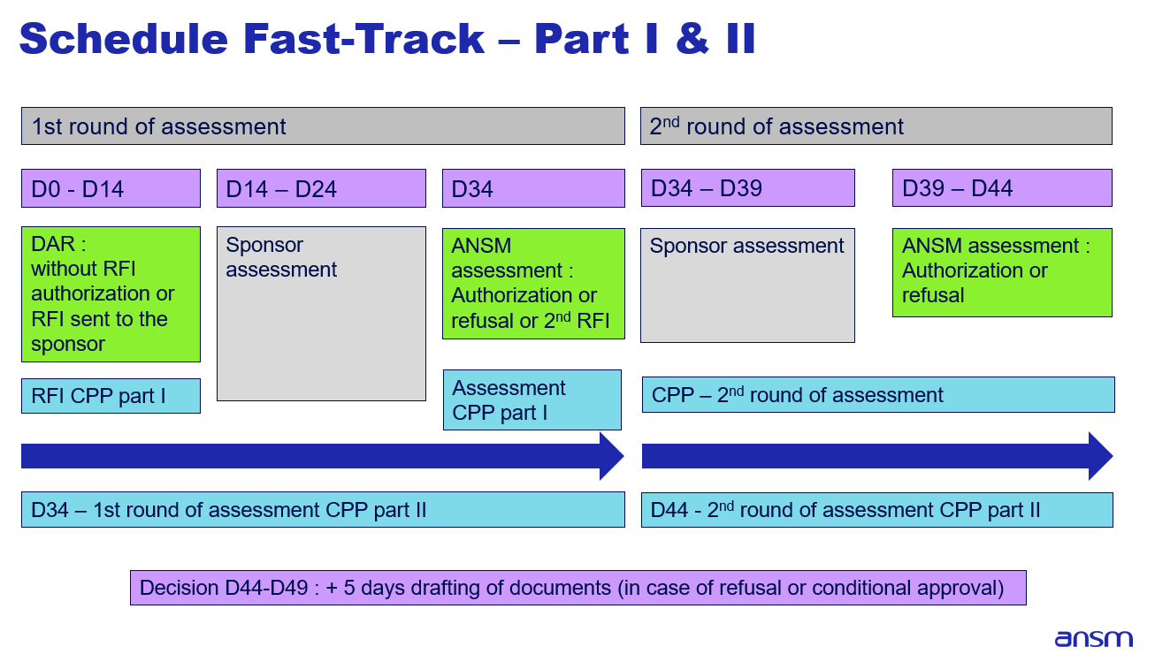
The validation period is not displayed here. D0 refers to the assessment start date.

Appendix 2: Schedule for ATMP

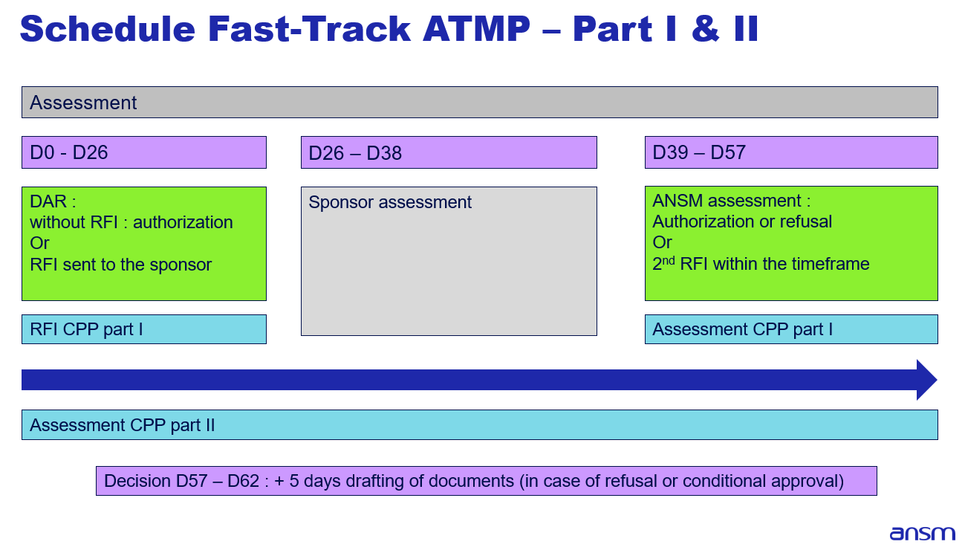

The validation period is not displayed here. D0 refers to the assessment start date.

